Case 8-CAN-NWC-Original Painting-

CAN-NWC-Original Painting-RAVEN TRANSFORMATION

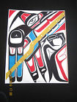

CAN-NWC-Original Painting-RAVEN TRANSFORMATION PANEL GITSXAAN FIRST NATIONS

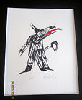

CAN-NWC-Original Painting-RAVEN GITSXAAN FIRST NATIONS

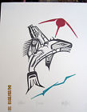

CAN-NWC-Original Painting FIERCE ORCA GITSXAAN FIRST NATIONS

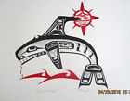

CAN-NWC-Original Painting BLOOD ON THE WATER HAIDA

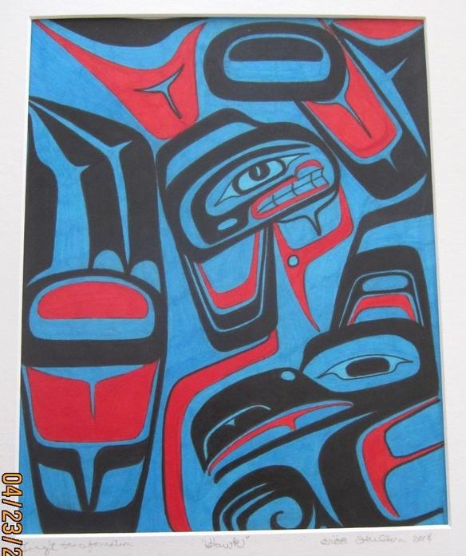

CAN-NWC-Original Painting-TRANSFORMATION PANEL-Tlingit

HAWK is by TLINGIT artist CROE HUDSON (pronounced Kray Hudson), Raven Clan. It is a Transformation panel style painting.

Custom inks of black and red create a formline from 2014 and measures approximately 11.5" X 15" and it is  matted. Signed and dated on the back of the painting. PALLETTE OF ARCHES PROFESSIONAL 300LB ARTIST STOCK AND DONE IN A MEDIUM OF GRAPHITE AND BARK ASH.